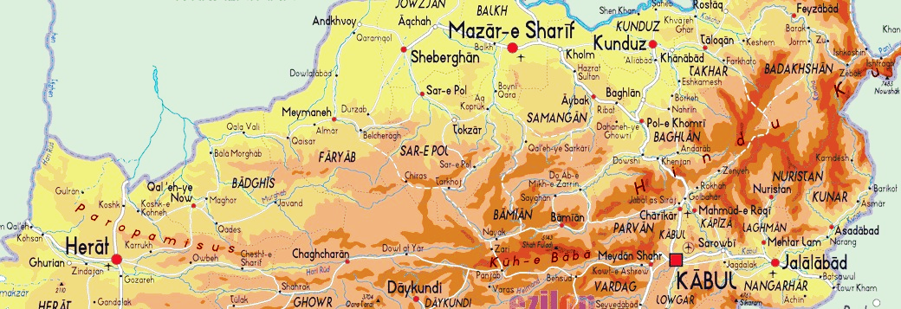

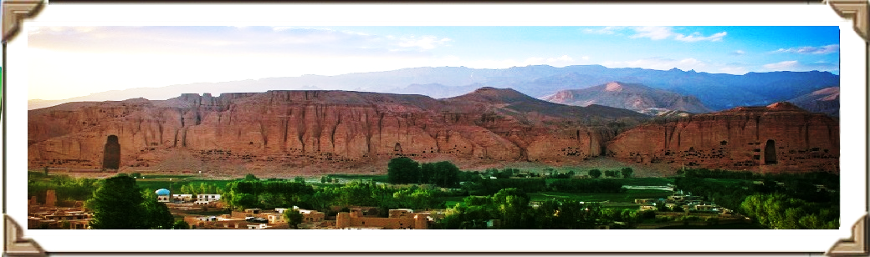

**Suggested six Days Buzkashi Trip:**

(Trip assumed to originate from Kabul, Airport with 1-2 people)

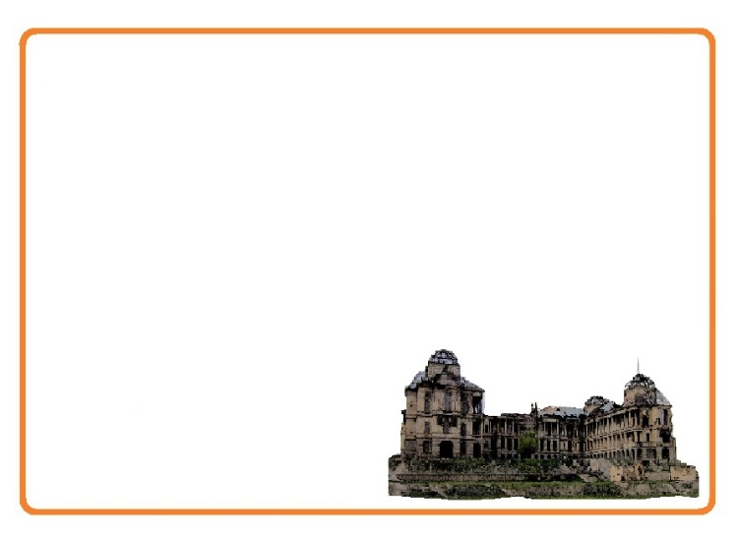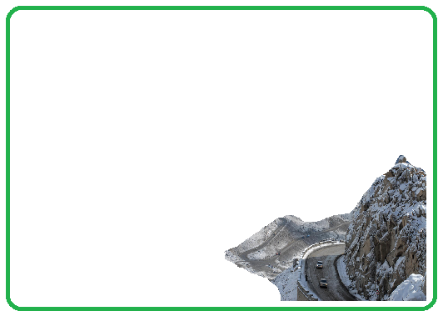January 13 – January 18, 2016

**Day 2, Road to Mazar-e-Sharif**

*Date: January 14th, 2016*

Journey to Mazar e Sharif will pass through Salang. The pass crosses the Hindu Kush Mountains but is now bypassed through the Salang Tunnel, which runs underneath it at a height of about 3,400 m. It links Charikar and Kabul in the south with Baghlan, Mazar-i-Sharif and Kunduz in the north. Before the road and tunnel were built, the main route between Kabul and northern Afghanistan was via the Shibar Pass, a much longer route which took three days. Now a series of tunnels built by the Russians in 1942 makes this an exciting way to cross the Hindu Kush.

Overnight at Hamsafar Guest House

**Day 1, Kabul Arrival**

*Date: January 13th, 2016*

Arrival and briefing at the hotel and a visit to Darrulaman Palace. The Palace was built in the early 1920s as a part of the endeavors of King [Amanullah Khan](https://en.wikipedia.org/wiki/Amanullah_Khan) to modernize Afghanistan. It was to be part of the new capital city that the king intended to build, connected to Kabul by a [narrow gauge railway](https://en.wikipedia.org/wiki/Narrow_gauge_railway). Then we will have time for Kabul National Museum. Its collection had earlier been one of the most important in Central Asia, with over 100,000 items dating back several millennia. With the start of the civil war in 1992, the museum was looted numerous times resulting in a loss of 70% of the 100,000 objects on display. Since 2007, a number of international organizations have helped to recover over 8,000 artifacts.

Overnight at Baharistan Arya GH

Day 1

Day 2

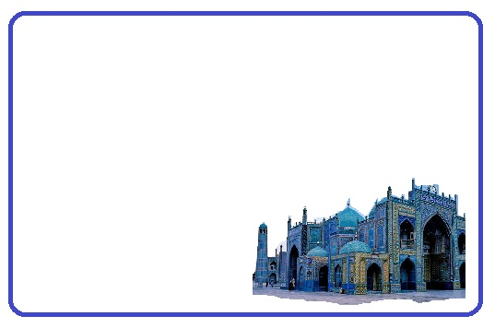

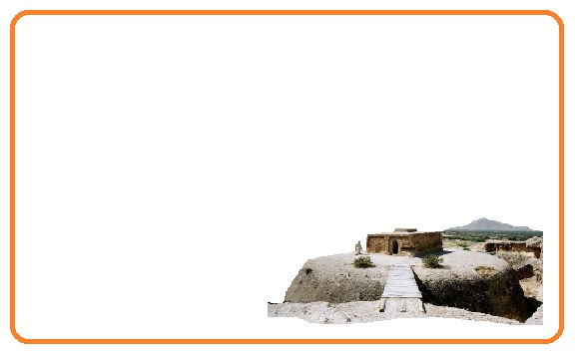

**Day 4, Mazar-e-Sharif –Samangan, Kabul**

*Date: January 16th, 2016*

Journey Back to Kabul and on the way we will have time to visit Takht-i Rustam (Haibak), literal meaning the throne of Rustam, named after Rustam, a king in Persian mythology, is a hilltop settlement, well-known archaeological site in Afghanistan, in the Takth i Rostam and the adjacent Buddhist caves and stupas on top of a hill, north of Hindu Kush passes. At this location, caves were hewn out of rocks and inhabited by Buddhists. The Buddhist stupa here is in the form of a mound. It represents the earliest link to the evolution of Buddhist architecture in Afghanistan.

Overnight at Baharistan Arya GH

**Day 3, Mazar-e-Sharif, Balkh and Buzkashi**

*Date: January 15th, 2016*

Journey to Balkh, an ancient city and center of Buddhism, Sufism and Zoroastrianism in what is now northern Afghanistan. While in Balkh, you visit Haji Piyada Mosque (the walking pilgrim) Tomb of Rabia Balkhi, Khoja Parsa Mosque and Bala Hisar, the ancient citadel build by Alexander the Great when he destroyed the Kurush (Persian empire) and crossed Amu Darya (Auxus River) in early 330, then married Rukhshana (Ruxana) in Bacteria (Balkh) and Ummul - Bilad (Mother of the cities) to Arabs. In the afternoon it is time to visit the Blue tiled Mosque of Ali and to see

the crazy game of Buzkashi

Overnight at Hamsafar Guesthouse

Day 3

Day 4

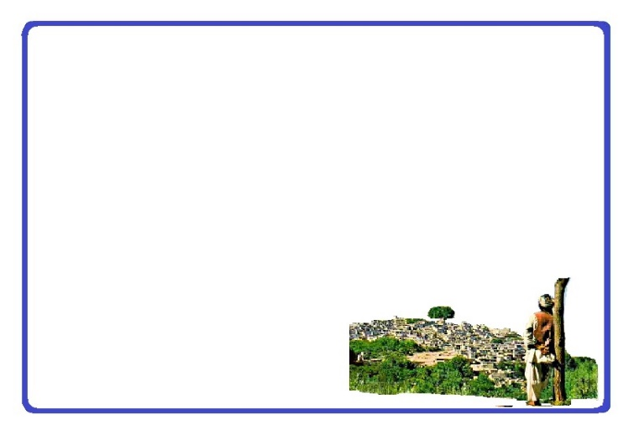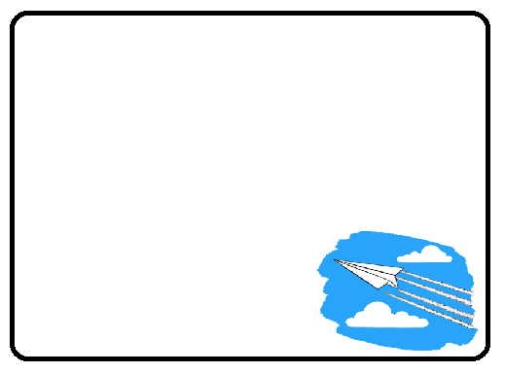

**Day 5, Kabul-Panjshir**

*Date: January 17th, 2016*

Journey to Panjshir and Tobm of Ahmad Shah Masood. Panjshir literally meaning "Five Lions", refers to five Wali (literally, *protectors*), spiritual brothers who were centered in the valley. Local legend has it that the five brothers built a dam for Sultan Mahmud of Ghaznawi in the early 11th century. Later, It was the site of the Panjshir offensives fought between the Democratic Republic of Afghanistan and the Soviets against the Mujahidin during the Soviet war in Afghanistan from 1980 to 1985. The valley again witnessed renewed fighting during the civil war in Afghanistan (1996-2001) between Taliban and the Northern Alliance under command by now national hero Ahmad Shah Masood. Lunch at the river bank and Journey back to Kabul.

Overnight at Baharistan Arya GH

**Day 6, Fly back (Good-bye)**

*Date: January 18th, 2016*

We will make sure to drop you at the airport on-time in order to make your flight back home.

Day 5

Day 6



**Tour Guide:**

There will be an Afghan English speaking guide for you during the whole trip

**Included in the trip:**

All accommodation, Breakfast, Drinks (Water), Lunch and Dinner, Transport/transfers, Local guide,

**Accommodation:**

Comfort, location, character and historical interest is considered and it will be based on you having a private room.

**Transportation:**

As your comfort and enjoyment of the journey is the first priority, we choose our vehicles and drivers based on local acceptance, road conditions and the length of journey.

**Safety:**

As you may know, travel to Afghanistan could be a little risky by all of their own and whilst we want you to have as much freedom as possible. We would like to say that your tour guide has the final word regarding changes in the itinerary for safety reasons.