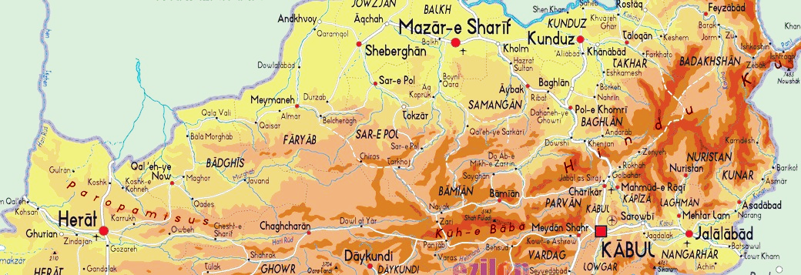

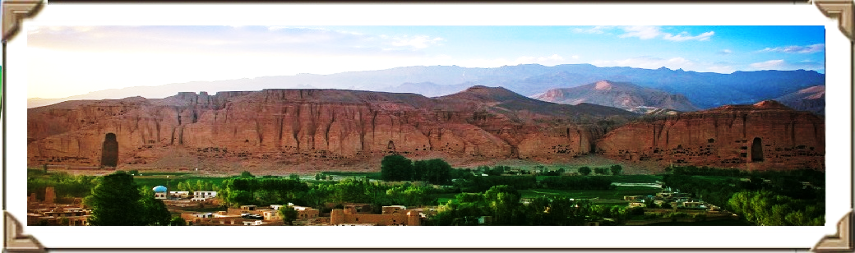

**Suggested Eight Days Bamyan Ski Trip:**

(Trip assumed to originate from Kabul, Airport with 1-4 people)

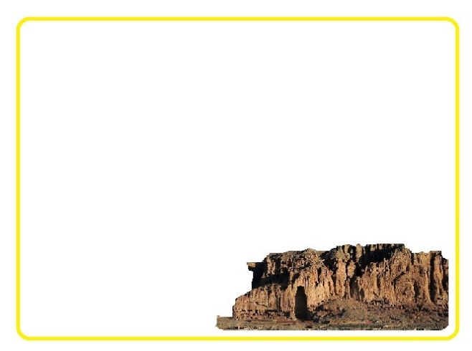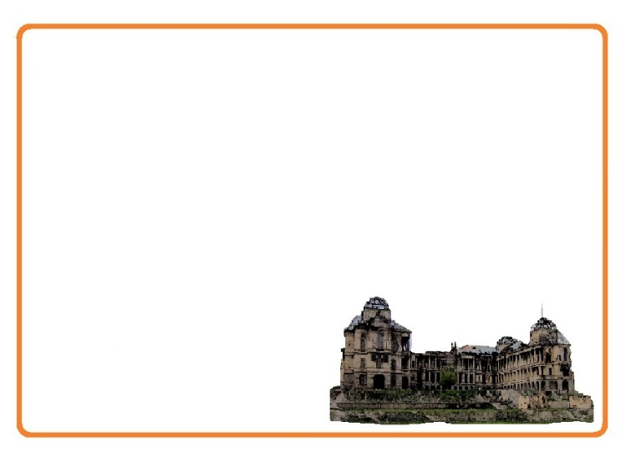February 10 – February 18, 2015

**Day 2, Kabul-Bamyan**

*Date: April 11th, 2016*

Early in the morning we will leave hotel to Kabul Airport aiming to fly to Bamyan and while in Bamyan we will have time to visit Buddha Niches. The Buddha’s of Bamyan were two 6th-century monumental statues of standing Buddha carved into the side of a cliff in the Bamyan valley in the peaceful Hazarajat region of central Afghanistan and  were dynamited and destroyed in March 2001 by the Taliban. There will be time after lunch to have a look around Bamyan Bazar and time for Photography at the best photo spots will be showing to you.

Overnight at Royal Hotel

**Day 1, Kabul Arrival**

*Date: February 10th, 2016*

Arrival and briefing at the hotel and a visit to Darrulaman Palace. The Palace was built in the early 1920s as a part of the endeavors of King [Amanullah Khan](https://en.wikipedia.org/wiki/Amanullah_Khan) to modernize Afghanistan. It was to be part of the new capital city that the king intended to build, connected to Kabul by a [narrow gauge railway](https://en.wikipedia.org/wiki/Narrow_gauge_railway). Then we will have time for Kabul National Museum. Its collection had earlier been one of the most important in Central Asia, with over 100,000 items dating back several millennia. With the start of the civil war in 1992, the museum was looted numerous times resulting in a loss of 70% of the 100,000 objects on display. Since 2007, a number of international organizations have helped to recover over 8,000 artifacts.

Overnight at Baharistan Arya

Day 1

Day 2

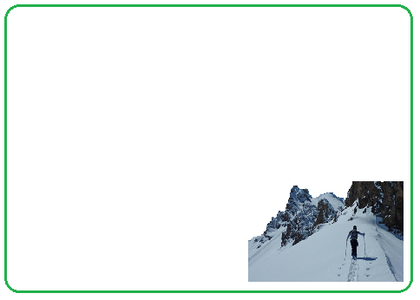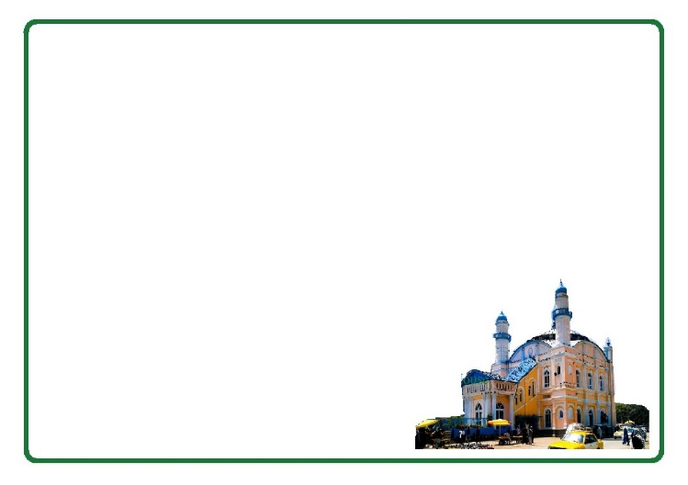

**Day 3, 4, 5, Ski in the slopes of Baba Mountains**

*Date: February 12th- 14th, 2016*

Skiing in Afghanistan is a new and unique activity that mainly takes place in the Central Afghanistan, Bamyan. Crossing from the local villages meeting motivated boys with their wooden homemade skies and going to Baba Mountain slopes provide an excellent skiing experience owing to their great height which makes for long descents. Since 2012, it has always been peaceful in Bamyan, which has led to an increase in skiing activity. Some of the most popular skiing locations in Bamyan are Qazan, Khushkak, Chapdara where you will be visiting a lot of westerners and locals walking up for hours and skiing down for minutes.

Overnight at Royal Hotel

**Day 6, Bamyan-Kabul**

*Date: February 15th, 2016*

Since flight is early in the morning, we will have time to visit Omar Landmine Museum and Shah Do Shamshira (the king with two swords) Mosque at the heart of Kabul city built by the King Amanullah khan in the memory of the Arab King who forced Kabul people in to Islam in the early 683 with his two swords. In the Afternoon, we will have a look around Chicken Street for some souvenirs then we will take you for an overall view of Kabul city at Bibi Mahro Hills

Overnight at Baharistan Arya

Day 3

Day 6

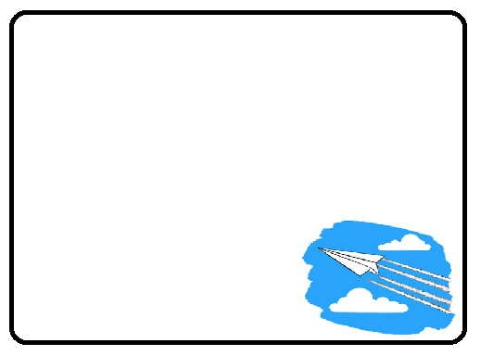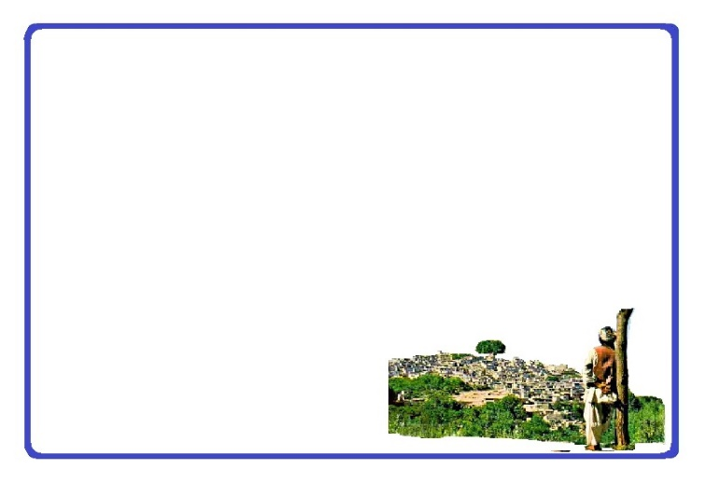

**Day 8, Fly back (Good-bye)**

*Date: February 17th, 2016*

We will make sure to drop you at the airport on-time in order to make your flight back home. If your flight is in the afternoon then we can have some time to have a look at the Bird Market where hundreds of types of birds are exhibited from Afghanistan and different parts of the world in the most original buildings and old bazaar of Kabul.

**Day 7, Kabul-Panjshir**

*Date: February 16th, 2016*

Journey to Panjshir and Tobm of Ahmad Shah Masood. Panjshir literally meaning "Five Lions", refers to five Wali (literally, *protectors*), spiritual brothers who were centered in the valley. Local legend has it that the five brothers built a dam for Sultan Mahmud of Ghaznawi in the early 11th century. Later, it was the site of the Panjshir offensives fought between the Democratic Republic of Afghanistan and the Soviets against the Mujahidin during the Soviet war in Afghanistan from 1980 to 1985. The valley again witnessed renewed fighting during the civil war in Afghanistan (1996-2001) between Taliban and the Northern Alliance under command by now national hero Ahmad Shah Masood. Lunch at the river bank and Journey back to Kabul.

Overnight at Baharistan Arya

Day 3

Day 14



**Tour Guide:**

There will be an Afghan English speaking guide for you during the whole trip.

**Included in the trip:**

All accommodation, Breakfast, Drinks (Water), Lunch and Dinner, Transport/transfers, Local guide, Round trip tickets Kabul-Bamyan/Bamyan-Kabul.

**Accommodation:**

Comfort, location, character and historical interest is considered and it will be based on you having a private room.

**Transportation:**

As your comfort and enjoyment of the journey is the first priority, we choose our vehicles and drivers based on local acceptance, road conditions and the length of journey.

**Safety:**

As you may know, travel to Afghanistan could be a little risky by all of their own and whilst we want you to have as much freedom as possible. We would like to say that your tour guide has the final word regarding changes in the itinerary for safety reasons.