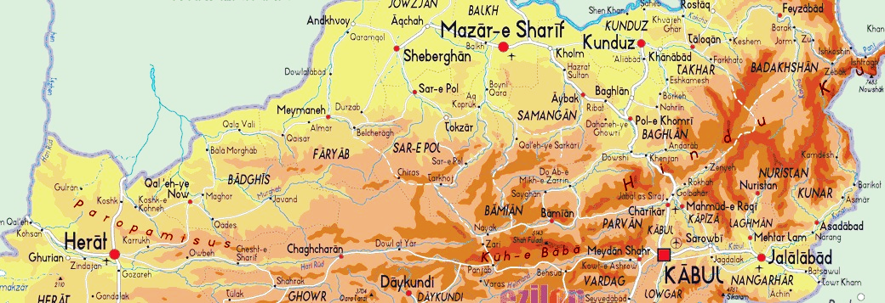

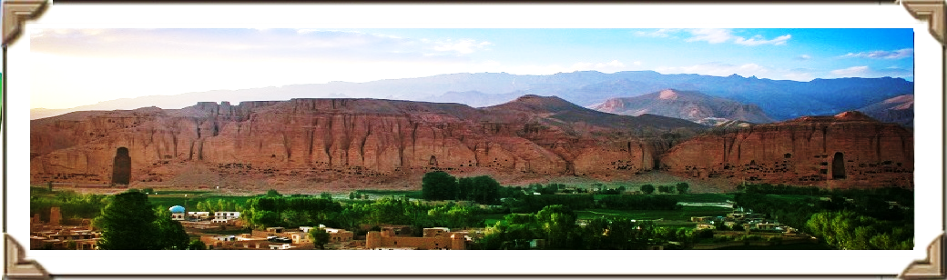

**Suggested Fourteen Days Grape Trip:**

(Trip assumed to originate from Kabul, Airport)

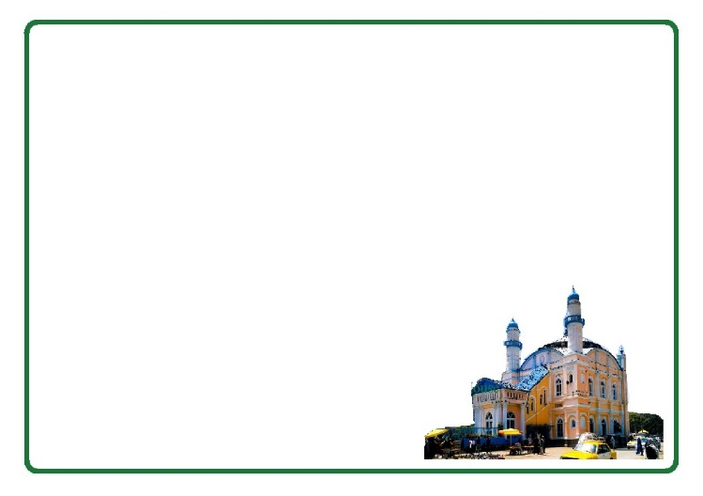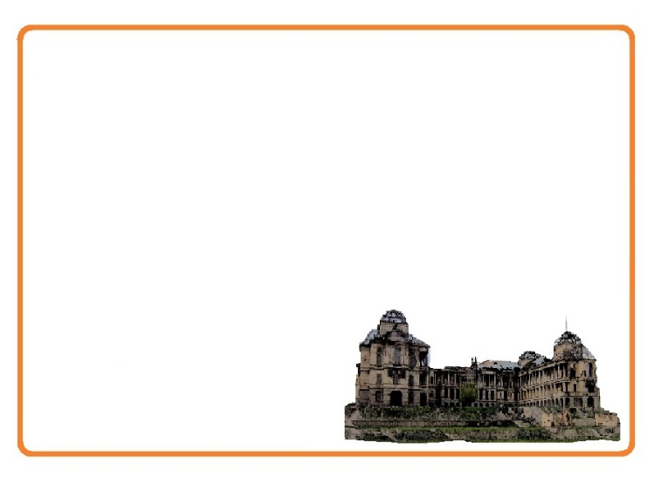July 15 – July 28, 2016

**Day 2, Kabul and around**

*Date: July 16th, 2016*

Day two is a day to visit Omar Landmine Museum and Shah Do Shamshira (the king with two swords) Mosque at the heart of Kabul city built by the King Amanullah khan in the memory of the Arab King who forced Kabul people in to Islam in the early 683 with his two swords. In the Afternoon, The Gardens of Babur, locally called Bagh-e Babur is a historic park in Kabul and also the last resting-place of the first Mughal emperor Babur. The gardens are thought to have been developed around 1528 when Babur gave orders for the construction of an ‘avenue garden’ in Kabul, described in some detail in his memoirs, the Baburnama. Then we will take you for an overall view of Kabul city at Bibi Mahro Hills

Overnight at ASSA 3

**Day 1, Kabul Arrival**

*Date: July 15th, 2016*

Arrival and briefing at the hotel and a visit to Darrulaman Palace. The Palace was built in the early 1920s as a part of the endeavors of King [Amanullah Khan](https://en.wikipedia.org/wiki/Amanullah_Khan) to modernize Afghanistan. It was to be part of the new capital city that the king intended to build, connected to Kabul by a [narrow gauge railway](https://en.wikipedia.org/wiki/Narrow_gauge_railway). Then we will have time for Kabul National Museum. Its collection had earlier been one of the most important in Central Asia, with over 100,000 items dating back several millennia. With the start of the civil war in 1992, the museum was looted numerous times resulting in a loss of 70% of the 100,000 objects on display. Since 2007, a number of international organizations have helped to recover over 8,000 artifacts.

Overnight at ASSA 3

Day 1

Day 2

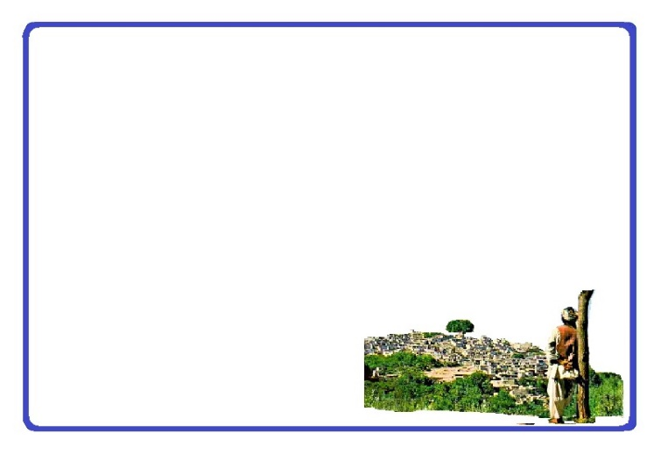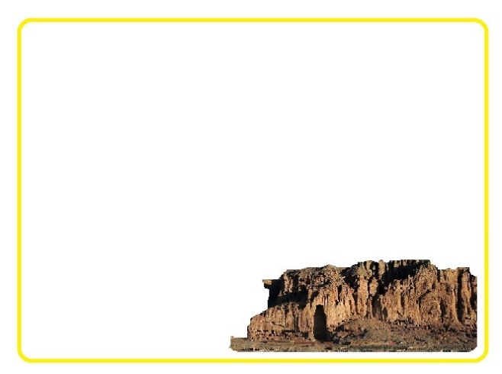

**Day 4, Kabul-Bamyan**

*Date: July 18th, 2016*

Early in the morning we will leave hotel to Kabul Airport aiming to fly to Bamyan and while in Bamyan we will have time to visit Buddha Niches. The Buddha’s of Bamyan were two 6th-century monumental statues of standing Buddha carved into the side of a cliff in the Bamyan valley in the peaceful Hazarajat region of central Afghanistan and  were dynamited and destroyed in March 2001 by the Taliban. There will be time after lunch to have a look around Bamyan Bazar and time for Photography at the best photo spots will be showing to you.

Overnight at Royal Hotel

**Day 3, Kabul-Panjshir**

*Date: July 17th, 2016*

Journey to Panjshir and Tobm of Ahmad Shah Masood. Panjshir literally meaning "Five Lions", refers to five Wali (literally, *protectors*), spiritual brothers who were centered in the valley. Local legend has it that the five brothers built a dam for Sultan Mahmud of Ghaznawi in the early 11th century. Later, It was the site of the Panjshir offensives fought between the Democratic Republic of Afghanistan and the Soviets against the Mujahidin during the Soviet war in Afghanistan from 1980 to 1985. The valley again witnessed renewed fighting during the civil war in Afghanistan (1996-2001) between Taliban and the Northern Alliance under command by now national hero Ahmad Shah Masood. Lunch at the river bank and Journey back to Kabul.

Overnight at ASSA 3

Day 3

Day 4

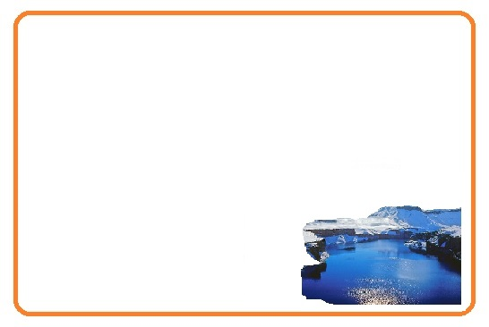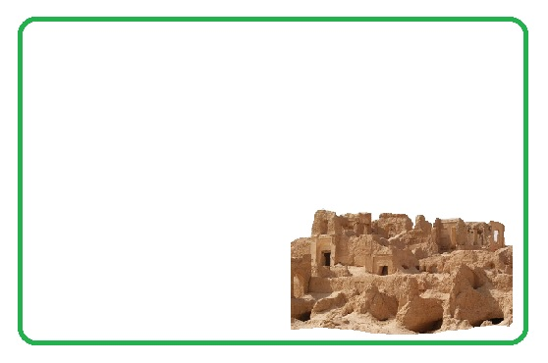

**Day 5, Band-e-Ameer**

*Date: July 19th, 2016*

Day five would be a day to visit the blue lakes of Band-e-Amir, a series of six deep blue lakes separated by natural dams made of travertine, a mineral deposit. The name Band-e Amir literally means *"Commander's Dam"* which is believed by some to be a reference to Ali, the first Imam of Muslims (Shias) and the fourth Caliph of Islam (to Sunnis) and The area is dominated by ethnic Hazaras, who make up around 23% of Afghanistan's population. Band-e Amir was to become Afghanistan's first national park in the 1960s but this was delayed due to political crises and the decades of wars. In 2004, Band-e Amir was submitted for recognition as a World Heritage site. In 2009, Band-e Amir was finally declared Afghanistan's first national park.As of 2013, about 6,000 local tourists visit the Band-e Amir National Park every year. Journey back to Bamyan.

Overnight at Royal Hotel

**Day 6, Bamyan and around**

*Date: July 20th, 2016*

Shahr-e Gholghola also (City of Screams) is 13th century city in Bamyan, Afghanistan which was conquered by Gengis Khan after months of surrounding. The ruins still remain close to the Bamyan town and Shahr-e Zuhak also known as *The Red City* is an historic city ruins in Bamyan, Afghanistan which was once home to 3,000 people. This city used to be primary defense for the basin. Then, we will have some time to visit the natural landscapes of the Darre Ajdaha (Dragon valley). Locals believe that Ali, killed a dragon and divided it in two pieces.

Overnight at Royal Hotel

Day 5

Day 6

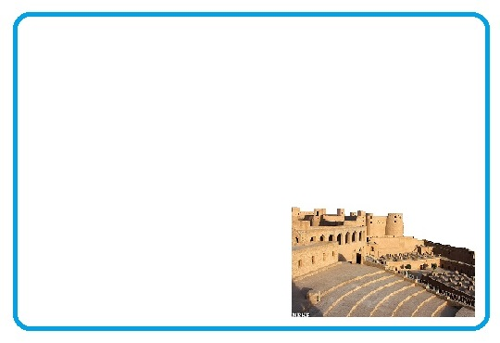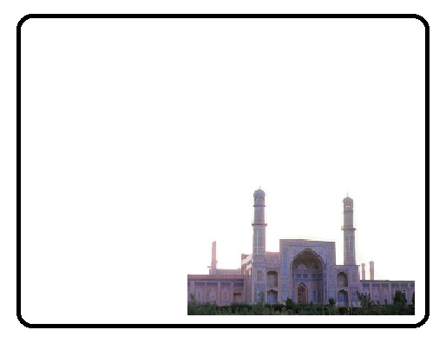

**Day 7, Bamyan –Kabul-Herat**

*Date: July 21st, 2016*

There is an early flight back to Kabul and then the breakfast. Then it will be the time to have a look at souvenir bazar in Kabul (Chicken Street). Then there will be time to visit the Western Cemetery in Kabul before going to the airport. The area was a British military camp or Cantonment and the site of the 1879 Siege of the Sherpur Cantonment in the Second Anglo-Afghan War. The cemetery houses memorials and graves for many fallen western soldiers who fought in various conflicts throughout the history of Kabul. It is managed by an Afghan father and son. In the aftermath, flight to Herat will happen in the afternoon.

Overnight at Yaqin Hotel

**Day 8, Herat and Around**

*Date: July 22nd, 2016*

First thing we do is to visit the Masjidi Jami or Friday Mosque, built by the Ghurid ruler Ghiyas ad-Din Ghori in 1200 (597 AH), and, after his death, the building was continued by his brother and successor Muhammad of Ghor and a short visit to the Tile factory of Herat. We will have time for Herat citadel, dates back to 330 BC, when Alexander the Great and his army arrived to what is now Afghanistan after the Battle of Gaugamela. Many empires have used it as a headquarters in the last 2,000 years, and was destroyed and rebuilt many times over the centuries.

The crazy game of Buzkashi will be in afternoon.

A look around Herat Bazaar

Overnight at Yaqin Hotel

Day 7

Day 8

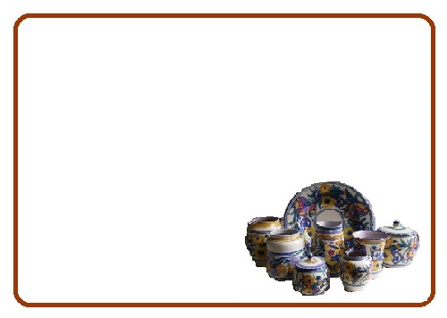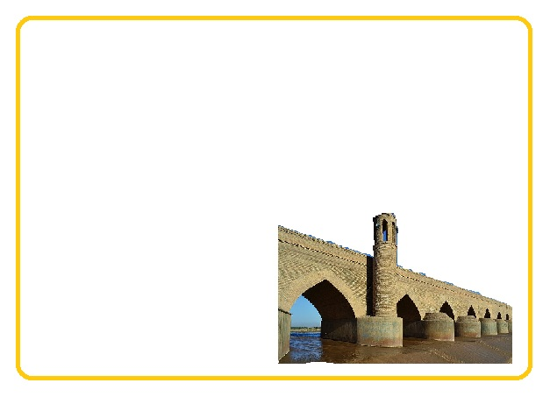

**Day 9, Herat and around**

*Date: July 23rd, 2016*

Tomb of Goharshad and Minarets of Herat, a much larger complex the Mosque and Madressa of Gawharshad. However, those architectural monuments were dynamited by officers of the British Indian Army in 1885, to prevent its use as a fortress if a Russian army tried to invade India. But hopefully, the Tomb and minarets are still standing. In the afternoon we will guide you to Guzargah Mosque and Puli Malaan, The fine old 22-arched bridge, believed to have been constructed by the Seljuks in the early 12th century. Local believe it is built by two sisters named Bibi Hur and Bibi Noor.

Dinner at Yaqin Hotel

**Day 10, Herat-Kabul, Istalif**

*Date: July 24th, 2016*

Stālif, a village 29 kilometers northwest of Kabul. The village was destroyed during the long-lasting wars around Kabul. It is famous for its handmade glazed potteries. Its name might derive from Greek *staphile* ("bunch of grapes") or Parachi *estuf* ("cow-parsnip"). Istalif was always renowned as one of the most beautiful places in Afghanistan – the Emperor Babur fell in love with it in the 16th century and used to hold parties in his rose garden and summer house there.

Birds Market will be shown to you in the afternoon

Overnight at ASSA 3

Day 9

Day 10

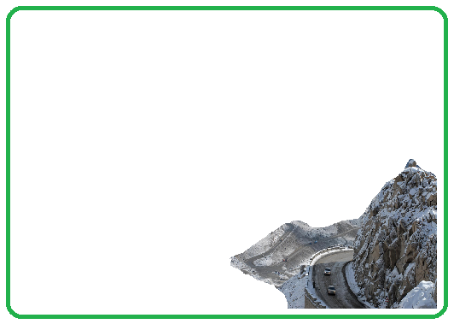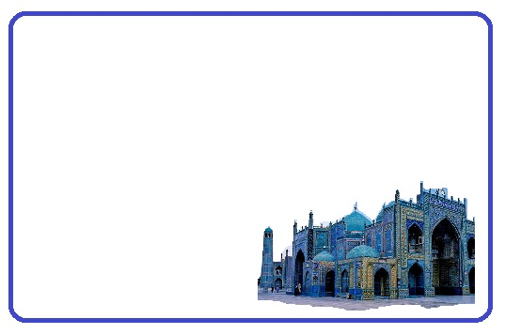

**Day 12, Mazar-e-Sharif and Balkh**

*Date: July 26th, 2016*

Journey to Balkh, an ancient city and center of Buddhism, Sufism and Zoroastrianism in what is now northern Afghanistan. While in Balkh, you visit Haji Piyada Mosque (the walking pilgrim) Tomb of Rabia Balkhi, a semi-legendaryfigure of Persian literature and was possibly the first woman poet in the history of New Persian poetry, Khoja Parsa Mosque and Bala Hisar, the ancient citadel build by Alexander the Great when he destroyed the Kurush (Persian empire) and crossed Amu Darya (Auxus River) in early 330, then married Rukhshana (Ruxana) in Bacteria (Balkh) and Ummul - Bilad (Mother of the cities) to Arabs. In the afternoon it is time to visit the Blue tiled Mosque of Ali.

Overnight at Ompratori Baran

**Day 11, Road to Mazar-e-Sharif**

*Date: July 25th, 2016*

Journey to Mazar e Sharif will pass through Salang. The pass crosses the Hindu Kush Mountains but is now bypassed through the Salang Tunnel, which runs underneath it at a height of about 3,400 m. It links Charikar and Kabul in the south with Baghlan, Mazar-i-Sharif and Kunduz in the north. Before the road and tunnel were built, the main route between Kabul and northern Afghanistan was via the Shibar Pass, a much longer route which took three days. Now a series of tunnels built by the Russians in 1942 makes this an exciting way to cross the Hindu Kush.

Overnight at Ompratori Baran

Day 11

Day 12

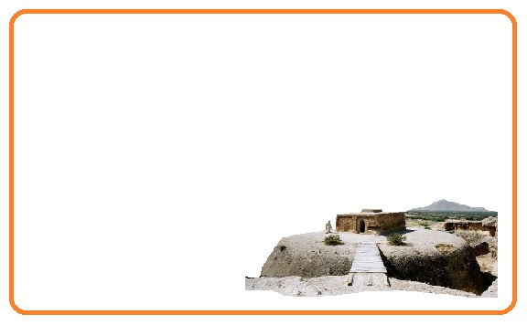

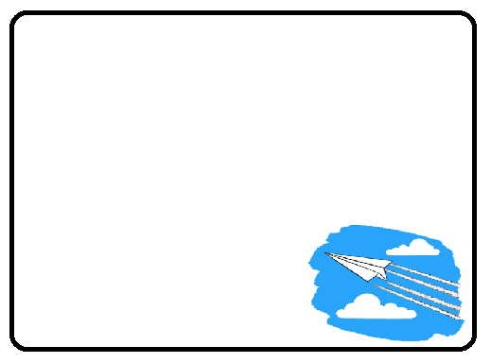

**Day 14, Fly back (Good-bye)**

*Date: July 28th, 2016*

We will make sure to drop you at the airport on-time in order to make your flight back home.

**Day 13, Mazar-e-Sharif –Samangan, Kabul**

*Date: July 27th, 2016*

Journey Back to Kabul and on the way we will have time to visit Takht-i Rustam (Haibak), literal meaning the throne of Rustam, named after Rustam, a king in Persian mythology, is a hilltop settlement, well-known archaeological site in Afghanistan, in the Takth i Rostam and the adjacent Buddhist caves and stupas on top of a hill, north of Hindu Kush passes. At this location, caves were hewn out of rocks and inhabited by Buddhists. The Buddhist stupa here is in the form of a mound. It represents the earliest link to the evolution of Buddhist architecture in Afghanistan.

Overnight at ASSA 3

Day 13

Day 14



**Tour Guide:**

There will be an Afghan English speaking guide for you during the whole trip

**Included in the trip:**

All accommodation, Breakfast, Drinks (Water), Lunch and Dinner, Transport/transfers, Local guide, Round trip tickets Kabul-Bamyan/Bamyan-Kabul and Round trip tickets Kabul-Herat/Herat-Kabul

**Accommodation:**

Comfort, location, character and historical interest is considered and it will be based on you having a private room.

**Transportation:**

As your comfort and enjoyment of the journey is the first priority, we choose our vehicles and drivers based on local acceptance, road conditions and the length of journey.

**Safety:**

As you may know, travel to Afghanistan could be a little risky by all of their own and whilst we want you to have as much freedom as possible. We would like to say that your tour guide has the final word regarding changes in the itinerary for safety reasons.